Civil war in Somalia

UNSC Resolution: | 775
Date of adoption: | 27-Aug-1992
Operative paragraph: | 5
Demand number: | 775,0511

Sarah-Myriam Martin-Brûlé

Wording of demand
- cooperate with the United Nations with a view to the urgent deployment of the United Nations security personnel called for in paragraphs 4 and 5 of its resolution 751 (1992) and as recommended in paragraph 37 of the Secretary-General's report

List of addressees of the demand
- Government of Somalia, United Somali Congress Faction

Short-term compliance

Description of the addressee(s)’ conduct

“
“Several of the Somali de facto authorities refused to agree to the deployment of United Nations troops to secure delivery of aid in areas of greatest need. UNOSOM troops in Mogadishu were fired upon and their vehicles and arms taken. Relief ships were prevented from docking, threatened and even shelled. Airports and seaports came under fire. Large sums of cash and relief aid were being extorted from donor agencies and organizations, and the lives of their personnel attempting to distribute supplies to starving people were being put in danger.”
UNOSOM
http://www.un.org/Depts/dpko/dpko/co_mission/unosom1backgr2.html#one

“As a result of Resolution 775, Aidid boxed in the fifty-member UN security forces, composed of Pakistanis at the airport. Further complicating the already complex situation for the UN in Mogadishu was Aidid’s decision in August to break away from the United Somali Congress (USC) to form his own militia, the Somali National Alliance (SNA) composed primarily of Hawiye sub-clan Habar Gidir members” Rutherford, Humanitarianism Under Fire. p. 52.

“On October 28, Aidid ordered Shaheen to clear the Pakistani troops from Mogadishu’s streets and evacuate the troops in Kismayu and Berbera. Aidid also alerted the UN that further military deployment under UNOSOM auspices would be countered violently by his forces and that UNOSOM coordinator for humanitarian assistance, Bassiouni, should leave Somalia “within forty-eight hours on the grounds that his activities went counter to the interests of Somalis’. Rutherford, Humanitariansim Under Fire. P.58

Meanwhile in Mogadishu, Aideed continued to threaten the five hundred
Pakistanis and block the unloading of relief supplies. Richard Clarke of the NSC
Staff asked whether the Joint Staff was doing evacuation planning. “No,” was the
reply; the objective should be finding ways to make the Pakistanis more effective.
From UN headquarters in New York, on 6 November, US Ambassador Edward
Perkins sent the State Department his judgment that the worldwide credibility of
UN peacekeeping efforts was at stake. The Serbs in Bosnia and the Khmer Rouge
in Cambodia would pay no heed to the Security Council “if bandits force it to
take flight in Somalia.” Consequently, he pressed for “a clear show of force and a
demonstrable willingness to use it” against “the smallest bully on the block.” Also
during this time, Senegal was organizing an African push for a UN-sponsored
trusteeship for Somalia. The massive unknowns of that course, Perkins argued,
created a good case for trying harder to make the current effort succeed. His cable
would be quoted frequently at interagency discussions.”

Walter Poole. “The Effort to Save Somalia: August 1992 – March 1994”
http://www.dtic.mil/doctrine/jel/history/somalia.pdf

“By a letter dated 24 November 1992 addressed to the President of the Council,40 the Secretary-General described a number of disturbing developments and conditions in Somalia which made it exceedingly difficult for UNOSOM to implement its mandate. General Aidid had declared that the Pakistani battalion would no longer be tolerated in the streets of Mogadishu; ordered the expulsion of the UNOSOM Coordinator for Humanitarian Assistance, on the grounds that his activities went counter to the interests
of the Somali people and his security could no longer be guaranteed; warned that any forcible UNOSOM deployment would be met with violence and that the deployment of United Nations troops in Kismayo and Berbera was no longer acceptable; and demanded the withdrawal of United Nations troops from Mogadishu airport.”

Repertoire of the Practice of the Security Council, 1989-1992, The Situation in Somalia
http://www.un.org/Depts/dpa//repertoire/89-92/CHAPTER%208/AFRICA/item%2006_Somalia_.pdf

Assessment

Short-term compliance
X No or marginal compliance (1) | Medium low compliance (2) | Medium high compliance (3) | Full or almost full compliance (4)

Considerations underlying the assessment

With the six months following the adoption of the resolution, the demand addressees did not cooperate with the United Nations with a view to the urgent deployment of the United Nations security personnel called for in paragraphs 4 and 5 of its resolution 751 (1992) and as recommended in paragraph 37 of the Secretary-General's report.

Medium-term compliance

Description of the addressee(s)’ conduct

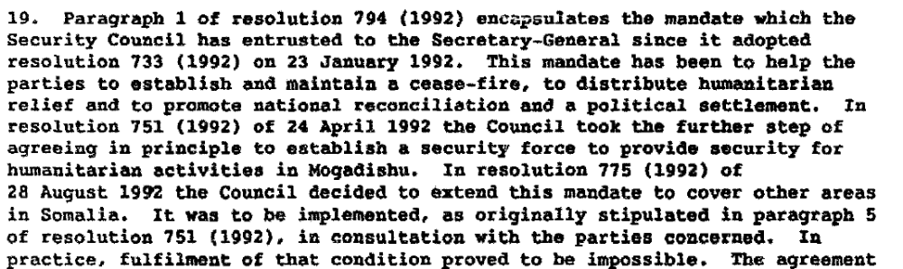

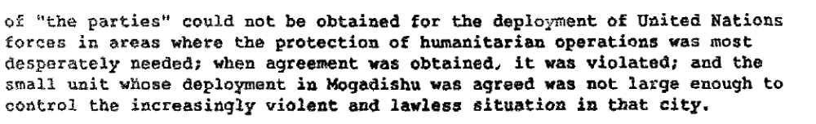

Report to the Secretary-General on the Situation in Somalia, 19 December 1992, S/24992

“In resolution 775 (1992) of 28 August 1992, the Council decided to extend this mandate to cover other areas in Somalia. This was to be implemented, as originally stipulated in resolution 751 (1992), in consultation with the parties concerned. In practice, fulfilment of that condition proved to be impossible. Agreement could not be obtained for the deployment of United Nations forces in areas where the protection of humanitarian operations was most desperately needed. When agreement was obtained, it was violated; and the small unit whose deployment in Mogadishu was agreed to was far from adequate to control the increasingly violent and lawless situation in the city.”

FURTHER REPORT OF THE SECRETARY-GENERAL SUBMITTED IN PURSUANCE OF PARAGRAPH 19 OF RESOLUTION 814 (1993) AND PARAGRAPH A 5 OF RESOLUTION 865 (1993),12 November 1993, S/26738,
http://www.pogar.org/publications/unresolutions/somalia/s26738-93e.pdf

“The Secretary-General stated that a number of factors had inhibited the distribution of food and other humanitarian assistance, especially in areas outside Mogadishu. He referred, in particular, to the lack of a government or governing authority capable of maintaining law and order, to the failure of various factions to cooperate with UNOSOM, to the extortion, blackmail and robbery to which the international relief effort was subjected, and to repeated attacks on the personnel and equipment of the United Nations and other relief agencies. (....) However, the Secretary-General stated that, despite the intensive efforts of his Special Representative, it had been possible to secure Somali consent to the deployment of only one battalion in one part of the country. (...)

Repertoire of the Practice of the Security Council, 1989-1992, The Situation in Somalia
http://www.un.org/Depts/dpa//repertoire/89-92/CHAPTER%208/AFRICA/item%2006_Somalia_.pdf

Assessment

Medium-term compliance
X No or marginal compliance (1) | Medium low compliance (2) | Medium high compliance (3) | Full or almost full compliance (4)

Considerations underlying the assessment

Within the two years following the adoption of the resolution, the demand addressees did not cooperate with the United Nations with a view to the urgent deployment of the United Nations security personnel called for in paragraphs 4 and 5 of its resolution 751 (1992) and as recommended in paragraph 37 of the Secretary-General's report.

Depth of demand

Assessment

Level of depth of demand
Low depth of demand (1) | Medium depth of demand (2) | X High depth of demand (3)

Considerations underlying the assessment

“(Sahnoun) was in the midst of difficult and sensitive give-and-take discussion with Aidid, who mistrusted Boutros-Ghali at best. At worst, Aidid thought the UN was targeting him unfairly as he controlled Mogadishu’s airport and harbor, locations where the UN troops would be deployed. The UNSC resolution for dramatically augmenting the UN military presence by sixfold threatened Aidid’s power base.”

Kenneth Rutherford. 2008. Humanitarianism Under Fire: The US and UN Intervention in Somalia. Kumarian Press, p. 58.

Adebajo thus explains Aideed’s troops reluctance to cooperate with peacekeepers:

“Mohammed Aideed only reluctantly agreed to (peacekeepers) presence when he realized it was inevitable. Both warlords felt that the peacekeepers would deprive them of the presidency. Aideed distrusted UN Secretary-General, Boutros Boutros- Ghali, whom he considered to be pro-Barre since Boutros-Ghali's tenure as Deputy Foreign Minister of Egypt.”

Adebajo, Adekeye. 2003. 'In Search of Warlords: Hegemonic Peacekeeping in Liberia and Somalia',International Peacekeeping,10:4,62 — 81
http://pdfserve.informaworld.com/125275_731244333_791531226.pdf

Level of confidence about coding decisions

Level of confidence about coding decision
Extremely high | X High | Moderate

Comments to IPI (if any)

